8-Bit Arithmetic Operations Using 8051

Aim:
To perform 8-bit arithmetic operations such as addition, subtraction, multiplication, and division using the 8051 microcontroller.

Apparatus Required:
Laptop with Keil uVision software

Algorithm:

For Addition:
- Load the first number from memory location 30H into register A.
- Load the second number from memory location 31H into register B.
- Add the contents of registers A and B.
- Store the result in memory location 40H.
- Store the carry (if any) in 41H.

For Subtraction:
- Load the first number from memory location 30H into register A.
- Load the second number from memory location 31H into register B.
- Subtract B from A.
- Store the result in memory location 40H.

For Multiplication:
- Load the first number from memory location 30H into register A.
- Load the second number from memory location 31H into register B.
- Multiply A and B.
- Store the lower byte of the result in memory location 40H.
- Store the higher byte of the result in memory location 41H.

For Division:
- Load the dividend from memory location 30H into register A.
- Load the divisor from memory location 31H into register B.
- Divide A by B.
- Store the quotient in memory location 40H.
- Store the remainder in memory location 41H.

Programs:
ORG 0000H ; Start program from address 0000H
LJMP MAIN ; Jump to the main routine

MAIN:
; --- Set up common data for all operations ---
MOV R1, #30H ; First operand
MOV R2, #20H ; Second operand
; Note: For this combined code, we use registers R1 and R2 for inputs.

; --- ADDITION (Result in R3, Carry in R4) ---
MOV A, R1 ; Load R1 into Accumulator A
ADD A, R2 ; Add R2 to A
MOV R3, A ; Store sum in R3 (Result: 50H)
; Check carry manually if needed, for simplicity we skip storing carry here in the combined code.

; --- SUBTRACTION (Result in R5) ---
MOV A, R1 ; Load R1 (minuend) into A
CLR C ; Clear the Carry flag (essential for SUBB to work correctly)
SUBB A, R2 ; Subtract R2 (subtrahend) from A with borrow
MOV R5, A ; Store difference in R5 (Result: 10H)

; --- MULTIPLICATION (Low byte in R6, High byte in B/R7) ---
MOV A, R1 ; Load first operand into A
MOV B, R2 ; Load second operand into B
MUL AB ; Multiply A and B (Product: A=Low byte, B=High byte)
MOV R6, A ; Store low byte in R6 (Result: 60H, as 30h * 20h = 600h)
; The high byte is already in B register, you could move B to R7 if desired: MOV R7, B

; --- DIVISION (Quotient in A, Remainder in B) ---
MOV A, R1 ; Load dividend into A
MOV B, R2 ; Load divisor into B
DIV AB ; Divide A by B (Quotient in A, Remainder in B)
MOV R7, A ; Store quotient in R7 (Result: 01H, integer division)
; The remainder is in B, you could store it in R0 if desired: MOV R0, B

STOP:
SJMP STOP ; Infinite loop to halt the program

END

Output:

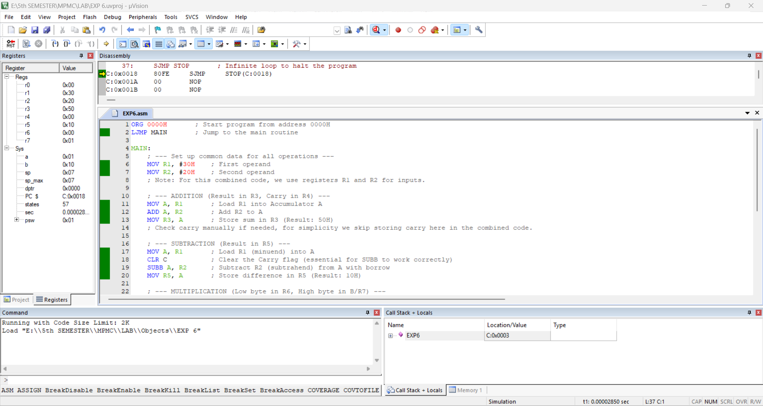

The results of addition, subtraction, multiplication, and division operations will be stored in memory locations 40H and 41H as specified in the program.

Result:
The 8-bit arithmetic operations using the 8051 microcontroller have been successfully executed and verified using Keil software.

